1) when user want to upgrade or downgrade its package user will go to subscription page

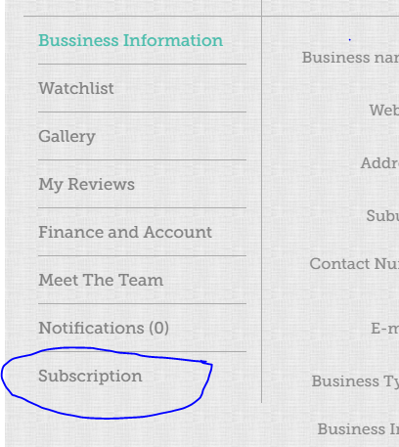

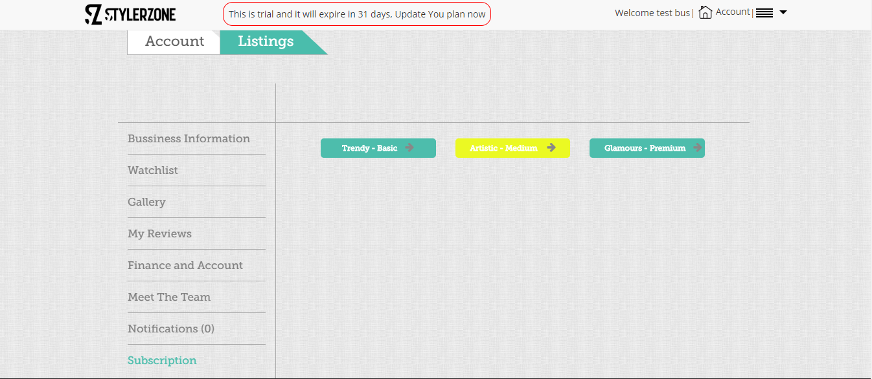

2) click on any package card form will open

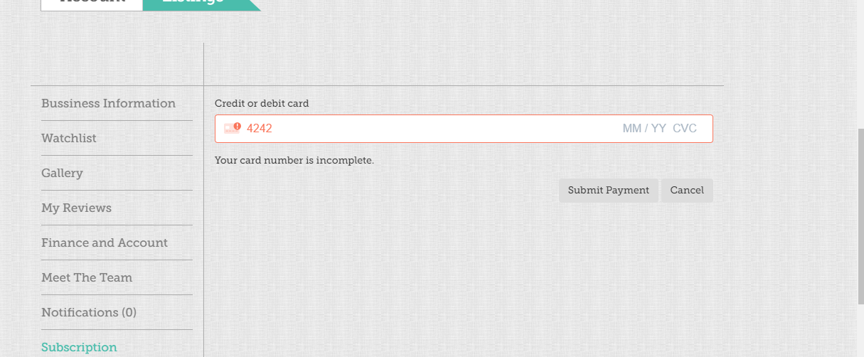

3) insert valid card info and click the submit payment and package will change.

valid card number are

4242424242424242 Visa  
4000056655665556 Visa (debit)  
5555555555554444 Mastercard  
2223003122003222 Mastercard (2-series)  
5200828282828210 Mastercard (debit)  
5105105105105100 Mastercard (prepaid)  
378282246310005 American Express  
371449635398431 American Express  
6011111111111117 Discover  
6011000990139424 Discover  
30569309025904 Diners Club  
38520000023237 Diners Club  
3566002020360505 JCB  
6200000000000005 UnionPay